[your school/setting/childminders name] is about to start using Tapestry for direct messaging between you and staff members. It will be turned on and ready for you to use on [date].
We’re switching over to using Tapestry for this in order to reduce the number of systems you need logins for in order to communicate with us, so from this point please no longer contact us through [however you’d like them to stop messaging]. Instead you can log into your Tapestry account and look for the Messaging icon/button.
The browser version of Tapestry will update automatically when it’s turned on, and you’ll see it in the top right hand corner, but if you want to use it via the Tapestry app, make sure the device you’re using has the most up to date version. One you have that, you’ll see the messaging section appear as a menu item at the bottom of your screen.

Browser:


Android app:
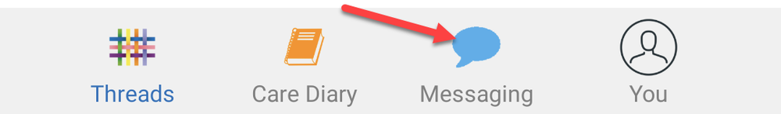

iOS app:

Messages you send and receive through this new feature will only be visible to the staff member you are speaking with and managers at [your school/setting/childminders name]. They will be subject to the same high technical security standards as posts made on Tapestry.
Our policies are the same as with [old system]:/We have some policies around messages which we'd appreciate you reading through and following:
- e.g. We’re keen to hear from you but please note that our staff have private lives too so won’t reply outside work hours. If it is an emergency please [give instructions for emergency contact].
- e.g. We hope it goes without saying that we won’t tolerate any abusive or inappropriate messages. If you send these we will revoke your access to the system.

If you’re having trouble accessing your Tapestry account please try resetting your password from the login screen, and if that doesn’t work get in touch with [manager name].
If you have any questions about this change, come and speak with [appropriate person].

